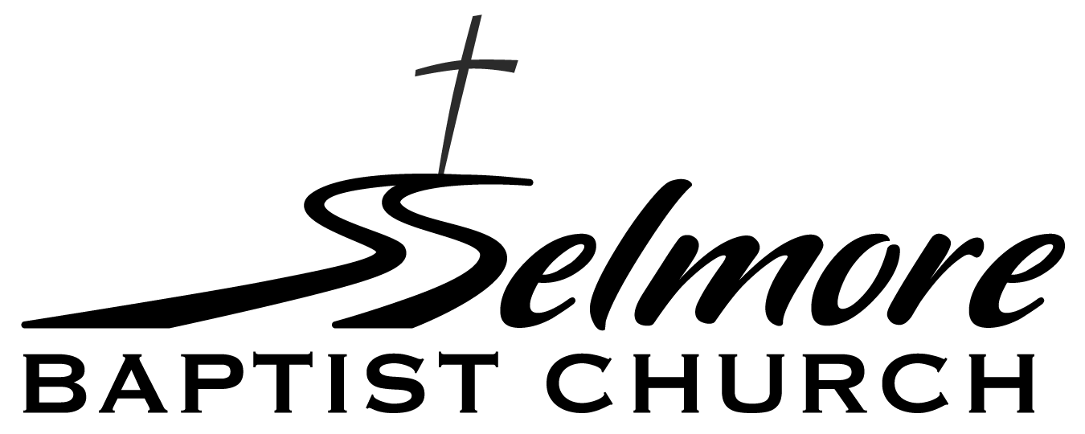
Ozark, Missouri
Position Description
Job Title: Minister of Youth & Children
Status: Full-Time Position
The following description is intended to describe the general nature and level of work being performed. It is not intended to be construed as an exhaustive list of all responsibilities, duties, and skills required. It is derived from, and subject to, the bylaws of Selmore Baptist Church.

POSITION SUMMARY:
The minister of youth and children is responsible to the senior pastor for planning, conducting and promotion of the children and student ministries of Selmore Baptist Church.

ESSENTIAL YOUTH MINISTER DUTIES AND RESPONSIBILITIES:
- Lead the youth ministry team to plan, promote, conduct and evaluate programs that provide spiritual growth and fellowship activities such as mission opportunities, camps, retreats, etc.
- Lead youth to recognize the call of God in their life unto salvation and spiritual growth.
- Relate the youth to the overall life of the church and the church to the needs of its youth.
- Strive to enlist the youth in worship, Bible study, prayer, and other Christian exercise.
- Conduct weekly services and/or ministry activities.
- Equip youth to walk with God as they enter college and/or their careers, by instructing them in evangelism, disciple-making, apologetics and methods of Bible study/interpretation.
- Visit the junior high and high school campuses; have personal contact with students at school- approved times.
- Maintain one-to-one contact with individual youth and their parents with an emphasis on reaching not just the youth, but the entire family.
- Be active in the community by attending things such as: sporting events, performances, competitions, etc.
- Counsel students and/or their parents on issues relating to: salvation, their overall spiritual life, and other choices faced by today’s youth. Be available to listen to and love our youth.
- Work with the youth ministry team to enlist and train adult workers. Motivate, instruct, and coordinate the activities of adult workers.
- Ensure adult workers are trained to lead youth to salvation and to nurture them in Christian development.

ESSENTIAL CHILDREN’S MINISTER DUTIES AND RESPONSIBILITIES:
- Lead the children’s ministry team to plan, promote, conduct and evaluate programs that call children to follow Christ, and equip them for a lifetime of walking with God.
- Work with the children’s ministry team to enlist, train, coordinate and motivate adult workers, including the weekly staffing of children’s classes.
- Work with volunteers to ensure all classrooms are inviting, clean and adequately supplied.
- Relate the children to the overall life of the church and the church to the needs of its children.

DUTIES AND RESPONSIBILITIES COMMON TO BOTH YOUTH AND CHILDREN:
- Build relationships with parents, and provide them with practical tools to disciple their children in the home.
- Coordinate the youth and children’s programs with the other ministries of the church by participating in scheduled church council meetings.
- Prepare an annual budget for both youth and children’s ministry for approval. Administer approved budgets.
- Work with the senior pastor to select/develop appropriate curriculum.
- Develop a comprehensive “discipleship path” that takes students from birth through high-school graduation.
- Provide regular recreational and fellowship activities for youth/children and their families.
- Coordinate with the church’s security team to implement policies and procedures to keep youth/children safe, including ensuring all workers have current background checks.
- Preach/teach, if called upon, in the absence of the senior pastor.
- Assist the senior pastor with pastoral care.
- Meet regularly with other pastors in the church for prayer, encouragement and accountability.
- Other duties as assigned.

KNOWLEDGE, SKILLS AND ABILITIES REQUIREMENTS:
- Spiritual maturity and a growing knowledge of God’s Word.
- Ability to speak confidently before groups, including preaching and teaching.
- Passion and ability to influence and affect youth and children’s lives with the gospel of Christ.
- Passion and ability to equip parents to disciple their youth and children in the home.
- Ability to relate with parents of youth and children.
- Ability to motivate and administrate adult volunteers.
- Basic ability to use essential computer software and social media.

ADDITIONAL REQUIREMENTS:
- Have a personal relationship with God through Jesus Christ.
- Have followed the biblical mandate of believer’s baptism.
- Meet qualifications set forth in 1 Timothy 3:1-7 and Titus 1:5-9.
- Commitment to ongoing personal spiritual growth.
- Must become a member of Selmore Baptist Church.
- Practice tithing for the support of the church.
- Attend staff meetings as required.
- Ability to deal with conflict in a healthy, biblical and constructive way.
- Sufficient good health to perform duties/responsibilities effectively.
- Must pass criminal and personal conduct background check.
- Abstain from the use of alcohol, marijuana, and all illegal drugs.
- Ability to listen effectively and to communicate clearly, both orally and in writing.
- Commitment to confidentiality regarding the church, church staff and church members.
- Must be diligent and well organized.
- Must be a team player.
- Must be in agreement with the “Baptist Faith and Message 2000.”

____________________________________________________________________________________
Physical demands and working conditions described here are representative of those an employee encounters while performing the essential functions of this job. Reasonable accommodations may be made to enable individuals with disabilities to perform the essential functions.

I have read this position description and fully understand the requirements. I agree to follow the requirements of the position and will perform all duties and responsibilities to the best of my ability.

_______________________________________ _______________________________________
Signature Date

